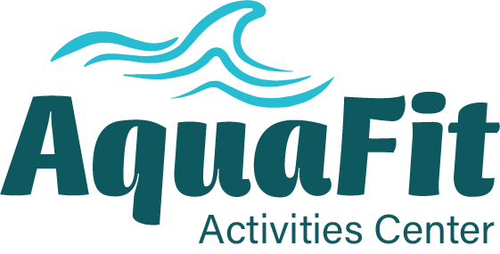
POOL SCHEDULE

Marc

57121 Sunnyslope Dr., Yucca Valley January 2026
(760) 365-9661
Monday | Tuesday |  | Wednesday | Thursday | Friday
7 AM  Advanced Aerobics  Wanda Stadum  8 AM  Intermediate Aerobics  Cecilia Neale  9 AM  Yoga in the Water  Sunny Evans  10 AM  Rockin’ & Rollin’ Aerobics  Kathryn Hilton  11 AM  Active Warm Water  Terry Medford  12 APM  Aerobics  Tommy Dodson     | 7 AM  Advanced Aerobics  Wanda Stadum  8 AM  Intermediate Aerobics  Cecilia Neale  9 AM  Active Warm Water  Scott McKone  10 AM  Intro to Aerobics  Donna Tomlinson  11AM  Walkie-Talkie  Joyce Johnson  12PM  No class  No class  6-8 PM  Active Adult Volleyball  Anita/Michal Brock | 7 AM  No Class  8 AM  Intermediate Aerobics  Cecilia Neale  9 AM  Yoga in the Water  Sunny Evans  10 AM  Basic Warm Water  Kathy Breslin  11 AM  Basic Warm Water  Kathy Breslin  12PM  Aerobics  Tommy Dotson  OUR HOURS ARE MON-FRI 7am to 1:30pm  WED 8am to 1:30pm |  | 7AM  Advanced Aerobics  Wanda Stadum  8AM  Intermediate Aerobics  Cecilia Neale  9AM  Active Warm Water  Scott McKone  10AM  Intro to Aerobics  Donna Tomlinson  11AM  Walkie-Talkie  Joyce Johnson  12PM  No class | 7 AM  Advanced Aerobics  Wanda Stadum  8 AM  Intermediate Aerobics  Sunny Evans  9 AM  Yoga in the Water  Sunny Evans  10AM Basic Warm Water  Kathy Breslin  11 AM  Active Warm Water  Terry Medford  12 PM  Aerobics Tommy Dodson  

